Algebra 1: Unit 14, Lesson H2

- Vivian conducted a survey among a group of male and female adults on whether they prefer to be contacted via text message or email. The partial results of the survey are summarized.
- Of those that preferred to be contacted via text message, $51.77\%$ were male.
- $47.43\%$ of the females preferred to be contacted via email.

An incomplete two-way relative frequency table of the data is shown.
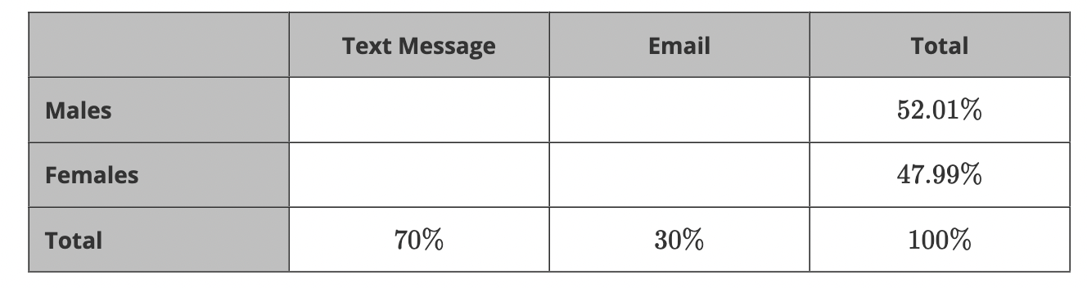
What percent of participants in the survey are females who prefer to be contacted by email?
$$14.23\%$$

- A survey was conducted among a group of male and female adults on whether they prefer summer weather or winter weather. The results of the survey are summarized in the two-way relative frequency table.
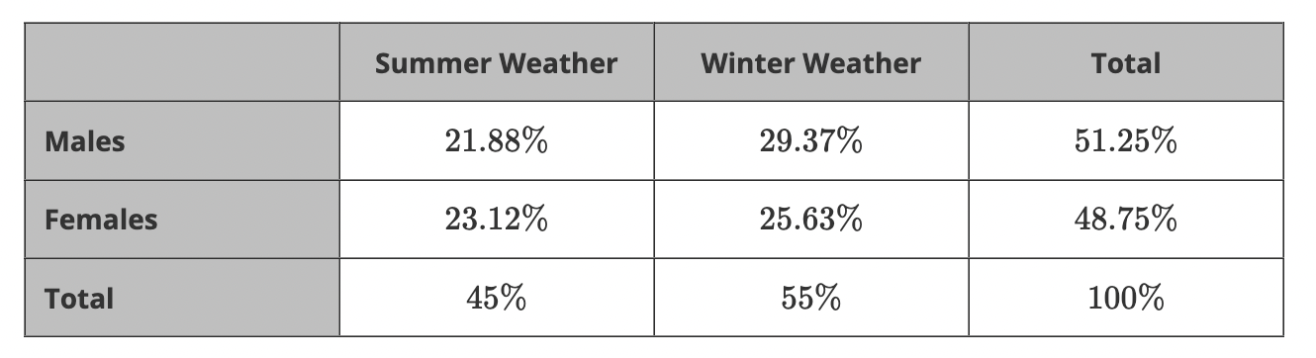
The value $\frac{21.88\%}{45\%}$ means what percent of all the people surveyed who were male preferred summer weather?
$$42.69\%$$

- A survey was conducted among a group of male and female adults on whether they prefer to read with a physical copy of a book or an eReader. The relative frequency table shown summarizes the results of the survey.
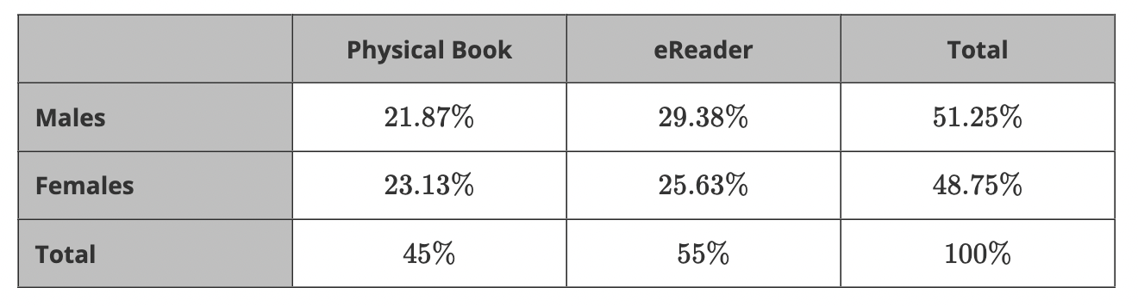
What is the conditional relative frequency of females that prefer to read a physical copy of a book?
$$23.13\%$$

